Learn DotNET

# Day 1: Introduction

Lesson 1: <https://www.youtube.com/playlist?list=PLayYhLZuuO9tV9PV2yeNQXolPc7XXw_7o>

# Day 2: Install SDK dotNET

Lesson 2: <https://www.youtube.com/playlist?list=PLayYhLZuuO9tV9PV2yeNQXolPc7XXw_7o>

# Day 3: Install IDE Visual Code

Lesson 3: <https://www.youtube.com/playlist?list=PLayYhLZuuO9tV9PV2yeNQXolPc7XXw_7o>

# Day 4: Create Library Use Hand-Made DLL

Lesson 4: <https://www.youtube.com/watch?v=Zmyvs29NFQo&t=6238s&ab_channel=gi%C3%A1o.l%C3%A0ng>

When call a function in another project in solution need to add reference

Image: <https://github.com/user-attachments/assets/88a0fb3f-179c-4f38-83b1-a08cd17604a8>

There are four ways to print in C#

Image: <https://github.com/user-attachments/assets/3ea8e38f-86c1-4be0-9733-c9d83acb79e8>

Var in C#: Type inferent - Suy luận kiểu ngầm của một Biến

Image: <https://github.com/user-attachments/assets/d21955fe-e010-4084-8e45-1273f40d6377>

# Day 5: Create Library Use Hand-Made DLL

Lesson 5: <https://www.youtube.com/watch?v=Wx_RHhEYGFQ&list=PLayYhLZuuO9tV9PV2yeNQXolPc7XXw_7o&index=9&t=4s&ab_channel=gi%C3%A1o.l%C3%A0ng>

DotPeek: use this IDE to decode file dll convert to code

DLL Library:

Image: <https://github.com/user-attachments/assets/ab610720-10ff-47e2-b410-946fc77b3c0d>

# Day 6: Create Library Use Hand-Made DLL

Lesson 6: <https://www.youtube.com/watch?v=iszYgh05RHI&list=PLayYhLZuuO9tV9PV2yeNQXolPc7XXw_7o&index=10&ab_channel=gi%C3%A1o.l%C3%A0ng>

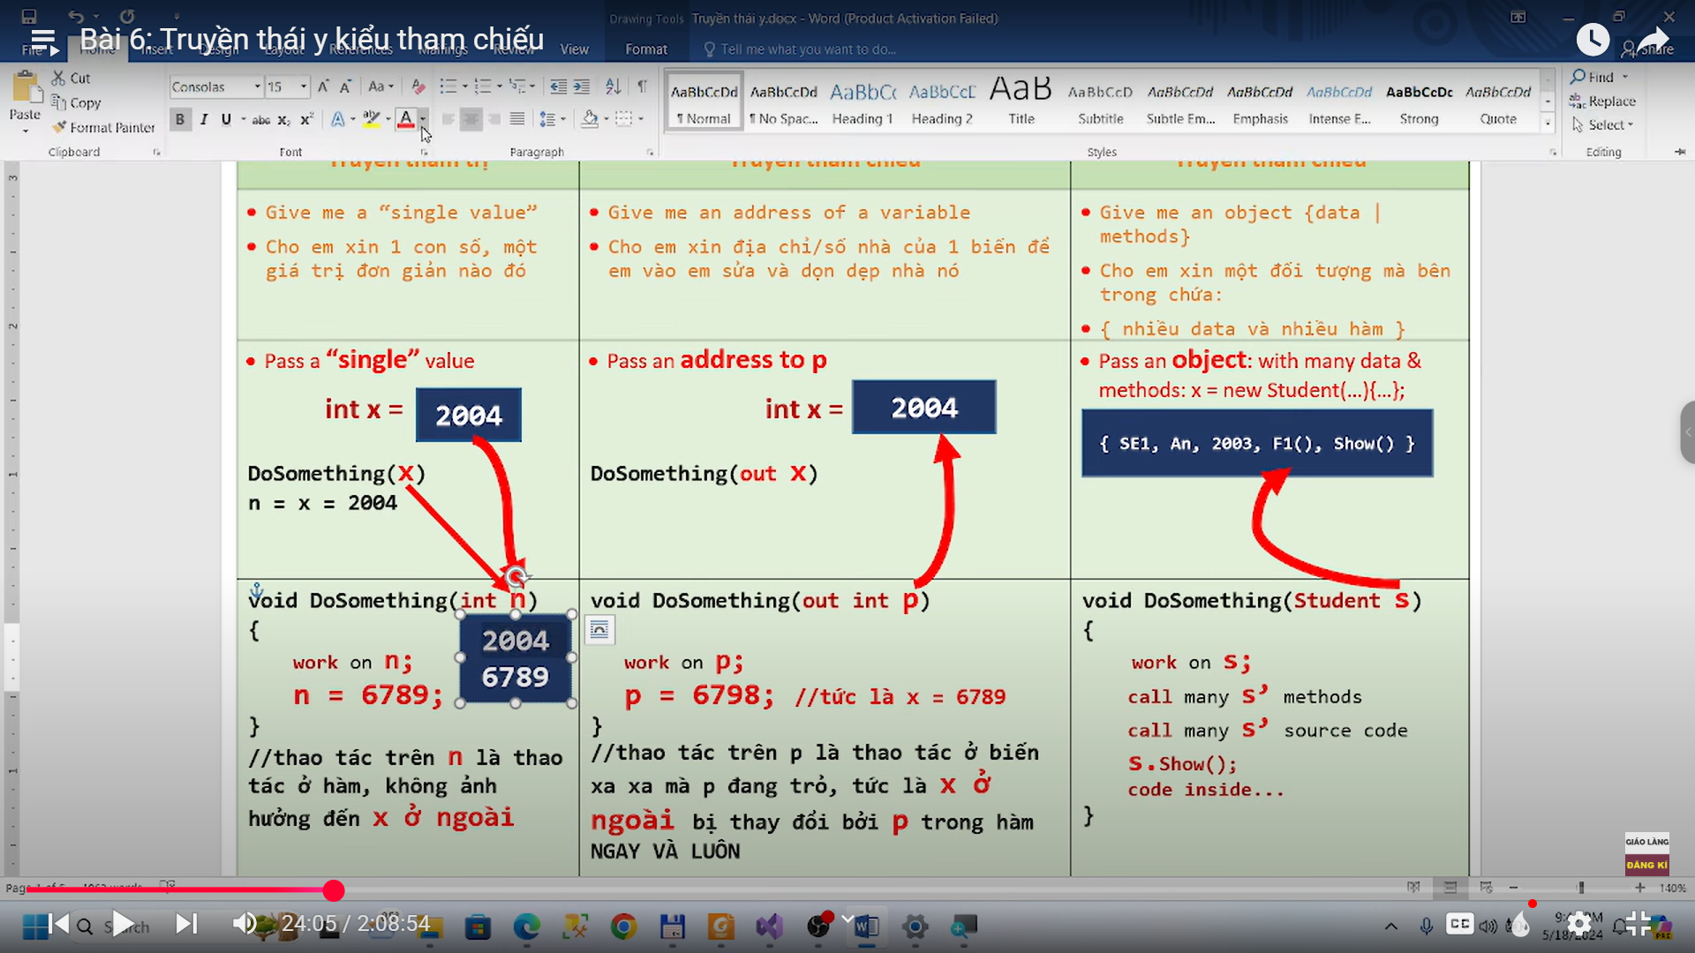

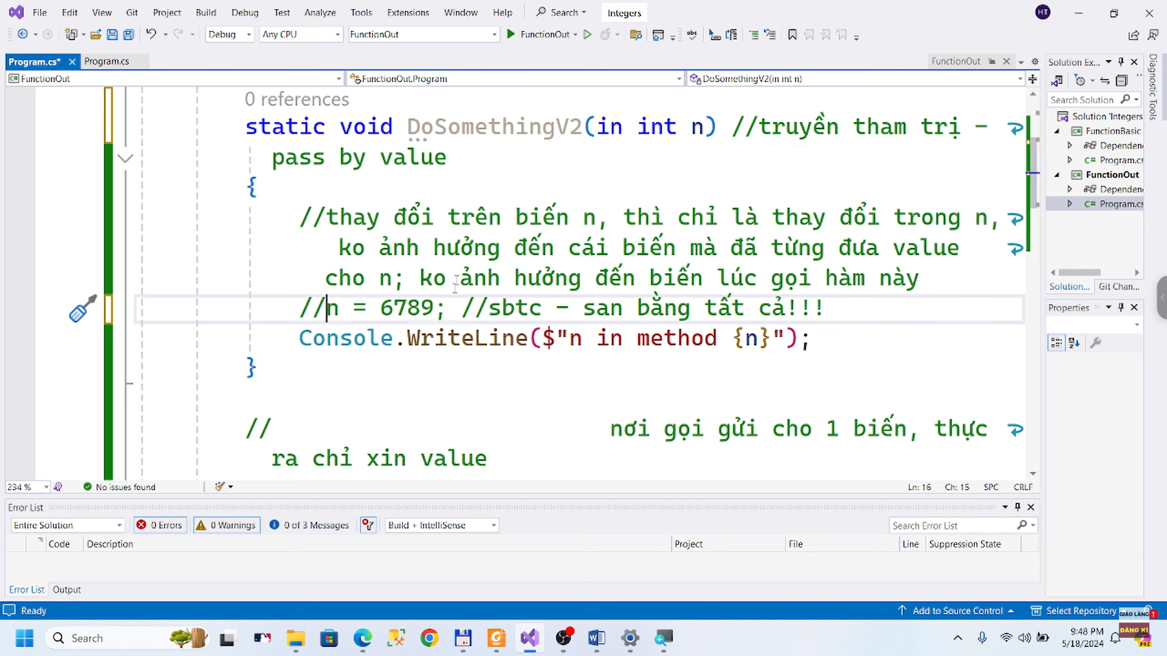

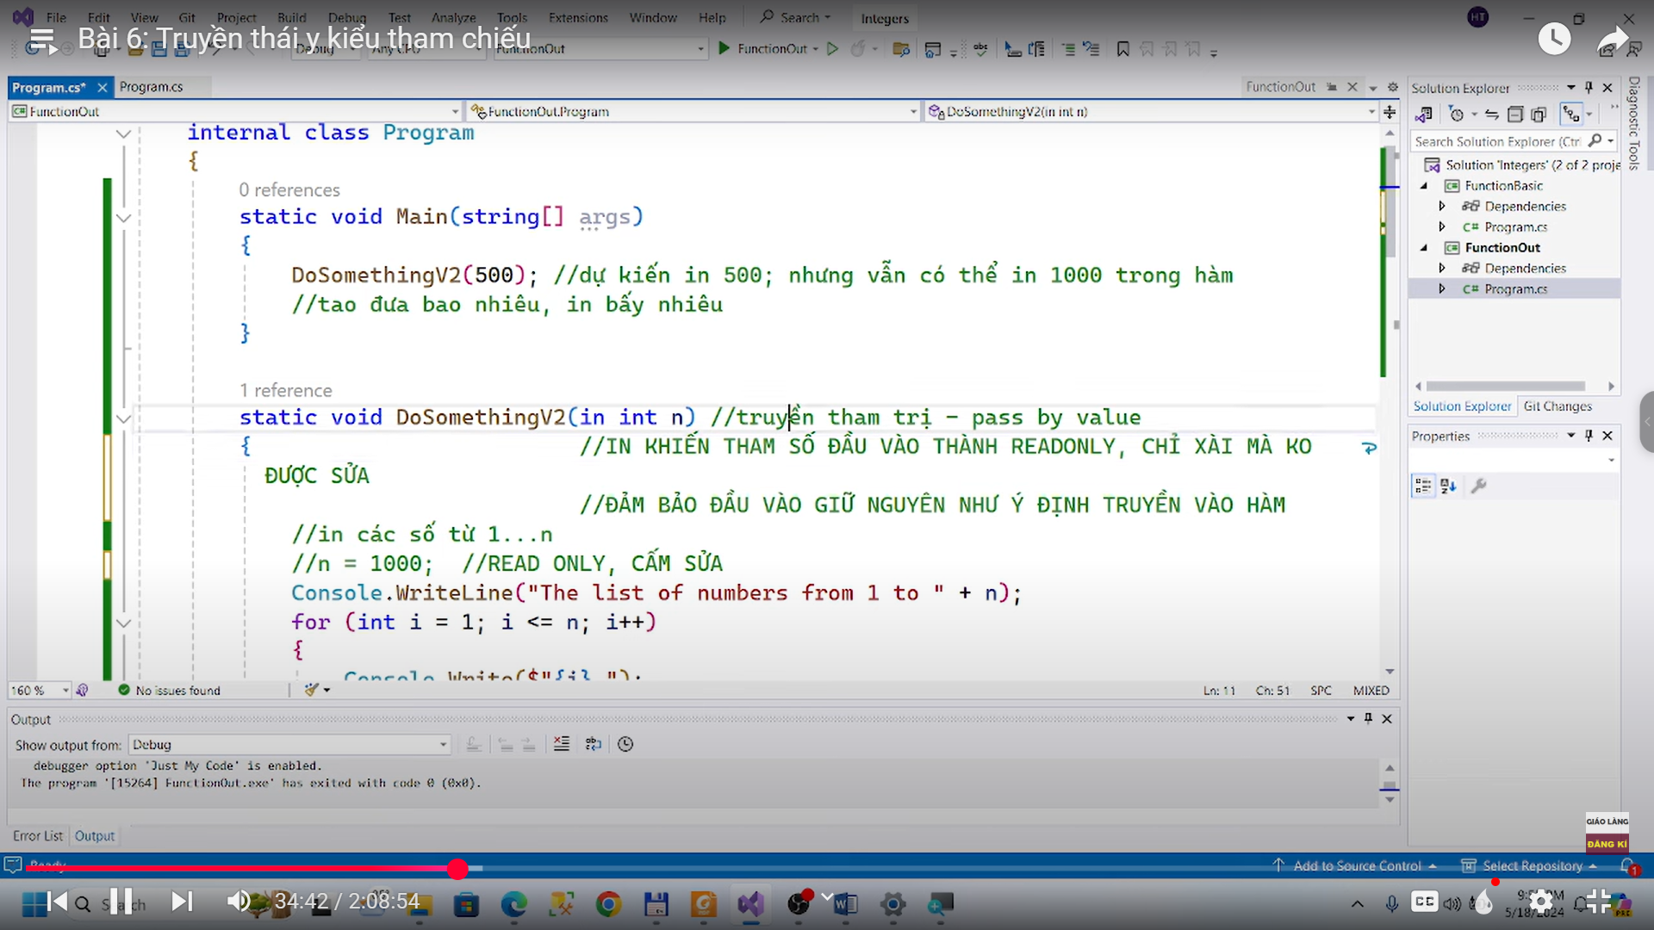

OUT and REF:

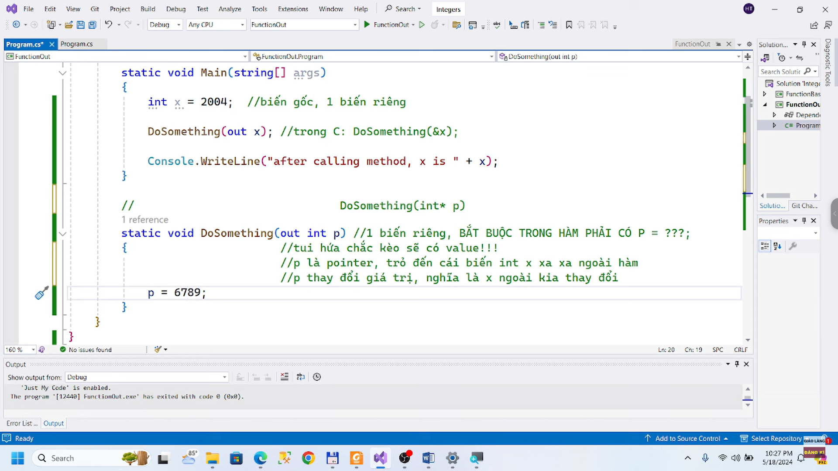 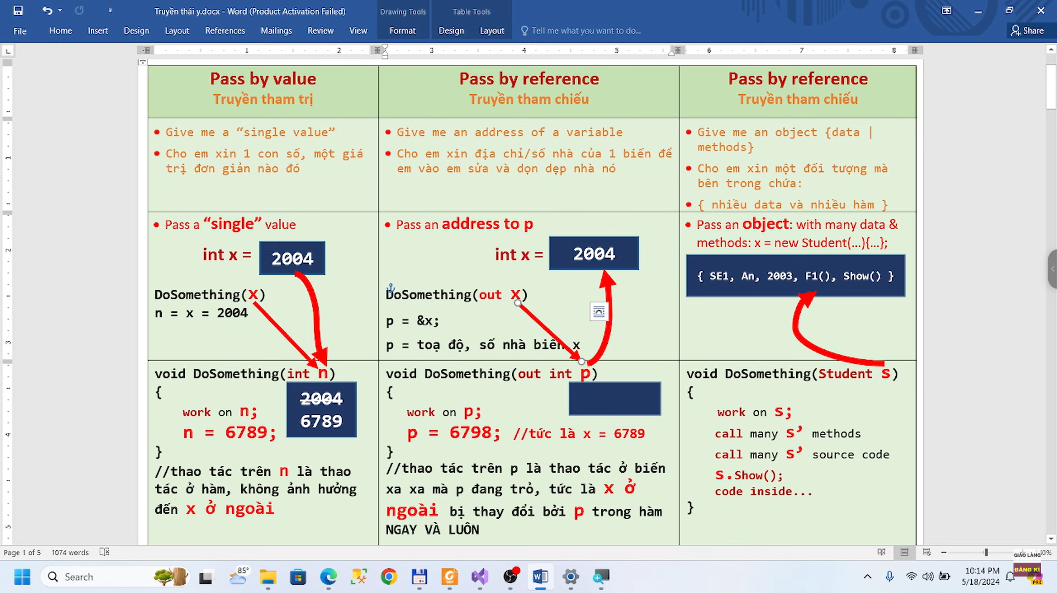 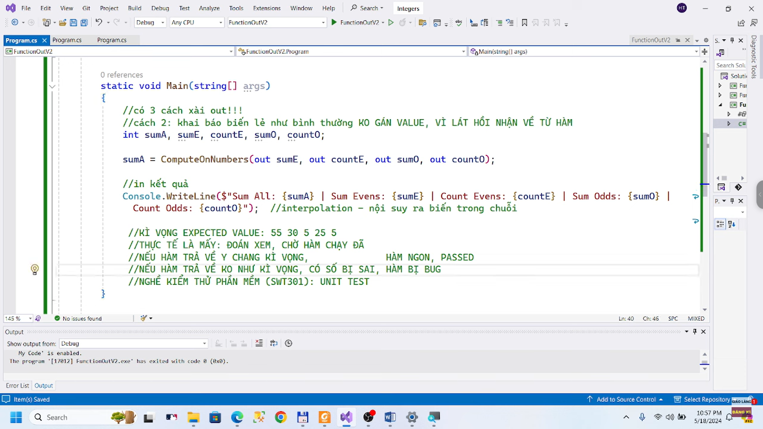 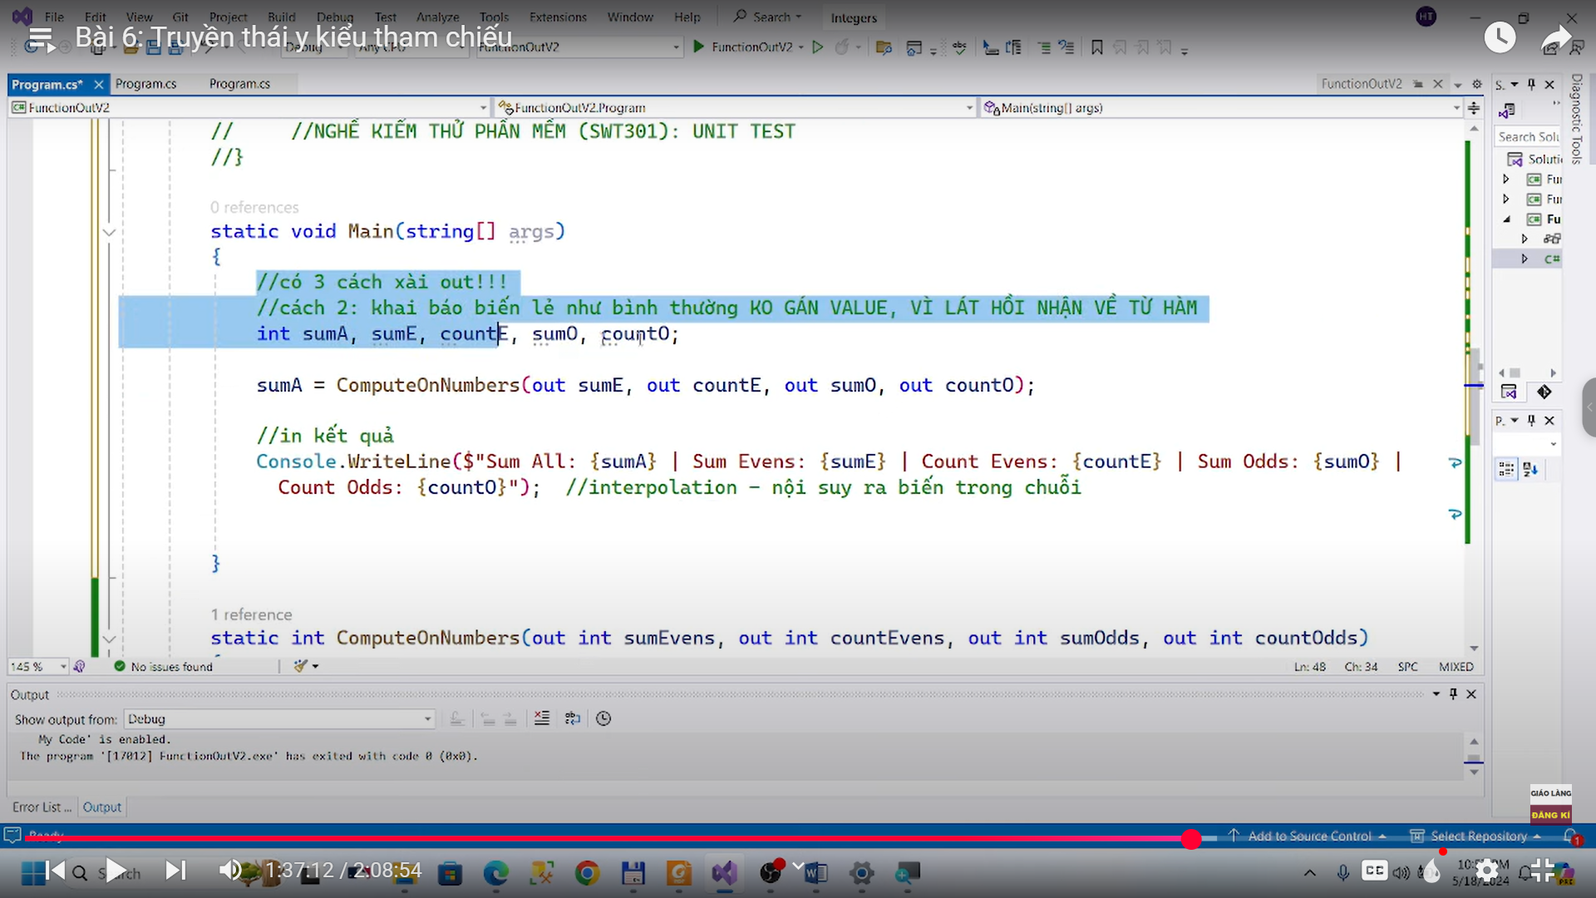 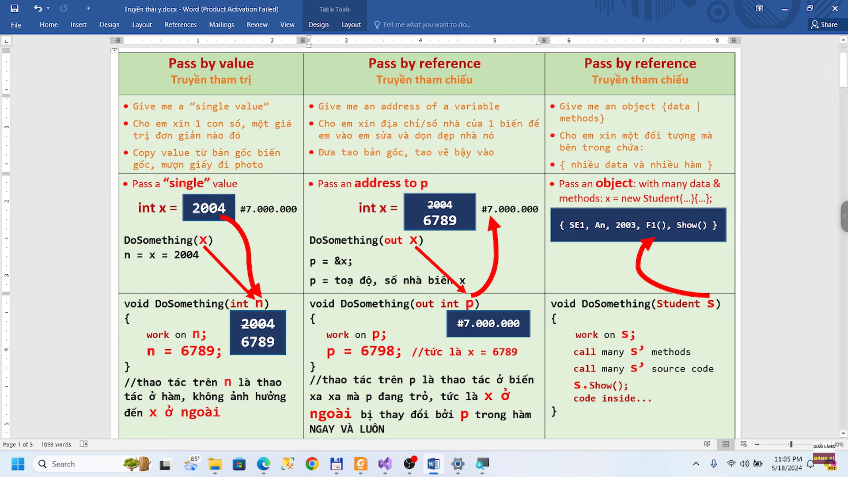

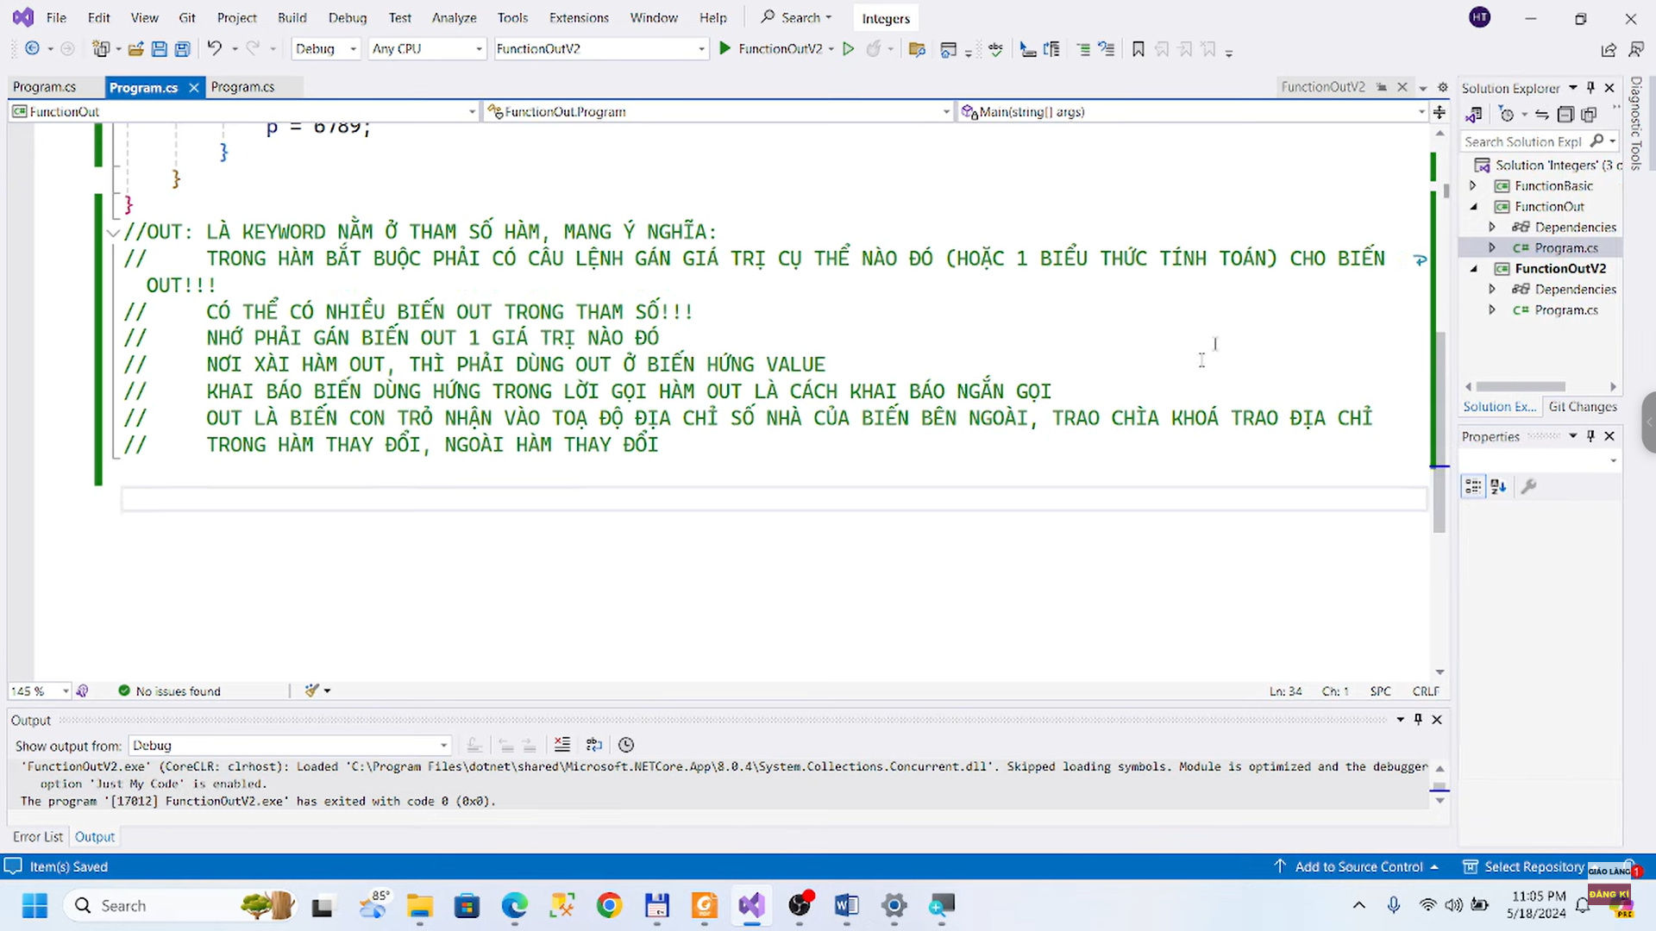

* REF: in C#

